Alice and her big sister sat under a tree one sunny day. Alice’s sister had a book, but Alice had nothing with her. She looked at her sister’s book. There were no pictures or conversations in it.
‘Why is she reading a book without pictures or conversations?’ she thought. ‘I’m bored. I know! I’ll look for some flowers.’ Then she thought,’ No, it’s too hot for that and I feel sleepy’
Suddenly, a white rabbit ran past her. It took a watch from its jacket and looked at it.’ Oh! Oh ! I’m going to be late!’ it said.
‘ That’s strange! A rabbit with a watch!’ said Alice.
She jumped up and ran after the animal. It ran down a large rabbit-hole, so Alice went down the hole too. She didn’t stop and ask,’ How am I going to get out again ?’ Alice fell down and down. But she fell very slowly and didn’t feel afraid. ‘What’s going to happen next?’ she wondered. She looked round. There were cupboards in the walls of the rabbit-hole. Some of the cupboards were open, and there were books in them. Sometimes she saw pictures. She looked down, but she couldn’t see any light. Down, down, down. ‘When will the hole end?’ she wondered. Perhaps I’m going to come out in Australia! I’ll have to ask the name of the country. ” Please, madam, is this Australia or New Zealand?” No, I can’t do that. They’ll think I’m stupid.’
She thought about her cat, Dinah. ‘What’s Dinah doing? Will they remember her milk tonight? Oh, Dinah! Why aren’t you here with me ? Perhaps there’s a mouse here and you can eat it!’
Suddenly, Alice was at the bottom of the hole. ‘ That didn’t hurt’ she said and sat up quickly. She could see the White Rabbit and she ran after him again. They were in a different rabbit-hole now.
‘ Oh, my ears and nose!’ the White Rabbit cried.’ It’s getting very late!’ He ran faster and vanished through another hole. Alice followed him through the hole. Now she was in a very long room. She looked round for the White Rabbit, but she couldn’t see him anywhere.
There were four doors in the room, but Alice couldn’t open them. Also, she couldn’t see the hole anywhere.’ How am I going to get out ?’ she wondered.
Then she saw a little table. It had a very small key on it. ‘Perhaps it will open one of the doors,’ she thought. She took the key and tried to open each door with it. But it was no good. The key was too small. `This key has to open something,’ she thought. Then she saw a very small door about 40 centimeters high. The little key opened it. She put her head down and looked through the door into a beautiful garden. She tried to walk through it, but she was too big. Sadly, she shut the door again and put the key back on the table.
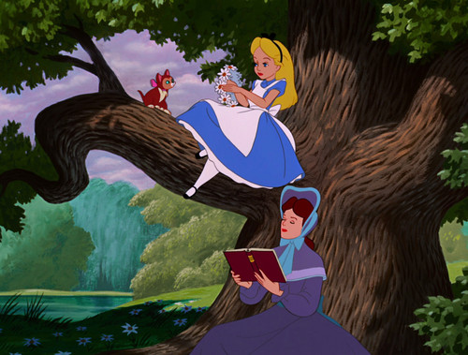
http://www.fanpop.com/clubs/alice-in-wonderland/images/35095981/title/beginning-scene-alice-wonderland-phot

Read the text and do the tasks
I. What is the genre (είδος) of the text? How do you know? (ex. Theatrical play, novel, short story etc)
________________________________________________________________________________________________________________________________________________________________________________________________________________________________________________

II. Choose the best title to the story

A. Alice in Australia B. Alice in Wonderland C. Alice and the Rabbit

III. Decide whether the statements are TRUE (T) or FALSE (F):

1 Alice was with her mother and they played tennis ___
2 A grey rabbit ran past Alice ___
3 The Rabbit was with a watch ___
4 Alice felt afraid and didn't go down the hole __
5 She fell very slowly___
6 Alice found herself in Australia___
7 Alice had a dog __
8 Alice ran after a cat ___
9 Alice found a small key ___
10 The small key was on a big table ___

IV. Find the synonyms (A) and the antonyms (B) to the following words in the text
A
1 dialogues - ______________
2 finish - _________________
3 quickly - _______________
4 silly - _________________

B
1 rainy - _________________
2 forget - ________________
3 open - _________________
4 interested - ___________

V. Answer the following questions.

1. What was unusual about the rabbit? _____________________________________________________________________________________________________________________________________________________________________________________________________________________________________________________________________

2. What did Alice see while she was falling down the hole? ____________________________________________________________________________________________________________________________________________________________________________________________________________________________________________________________________________________________________________________________________________________________

3. What events happened in the story that couldn't happen in real life?
_________________________________________________________________________________________________________________________________________________________________________________________________________________________________________________________________________________________________________________________________________________________

4. What did Alice worry about when she fell down the rabbit hole? Prove it with the words from the text
_____________________________________________________________________________________________________________________________________________________________________________________________________________________________________________________________________

VI. Describe the picture in your own words (write what is happening in it and what/who you see)
________________________________________________________________________________________________________________________________________________________________________________________________________________________________________________________________________________________________________________________________________________________________________________________________________________________________________________________________________________________________________________________________________________________________________________________________________________________________________________________________________________________________________________________________________________________________________________________________________________________________________________________________________________________________

VII. Do you like the story? Why? / Why not?
_____________________________________________________________________________________________________________________________________________________________________________________________________________________________________________________________________________________________________________________________________________________

(downloaded and adapted from Busy Teacher)

